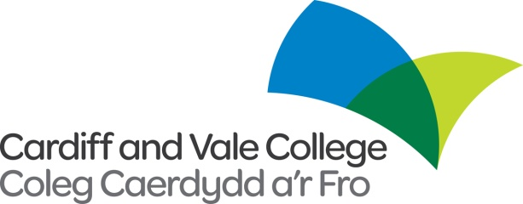

**Internal / External Vacancy**

**Ref: 12113**

**Job Title:**  **Work Based Learning Data Compliance Administrator**

**Contract: Permanent, Full Time**

**Hours: 37**

**Salary:** **£21,030 - £22,469 per annum**

An exciting opportunity has arisen for a Work Based Learning Data Compliance Administrator within the Work Based Learning department at Cardiff and Vale College. This role will be based across campuses.

Responsibilities include:

* Data input ensuring accuracy at all times and compliance with CAVCA internal data process.
* Cross checking of data inputted and documentation processes
* Day to day management of the data of assigned internal staff and sub-contractors.
* Record reviews, achievements, change of circumstance/ suspensions to learning and leaver destinations on Maytas system following appropriate procedures.
* To record and maintain learner/employer Health and Safety information on Maytas system following and complying to point 1 above.
* To work with the WBL Data Compliance Manager and WBL Assistant Data Team Leader to uphold the accuracy, integrity and compliance of data within Welsh Government regulations
* To assist WBL Assistant Data Team Leader to ensure data corrections are carried out within given timescale.
* To undertake general administration duties including email/verbal queries from assigned internal staff and sub-contractors.
* Produce monthly reports for sub-contractors:
* Welsh language skills would be desirable for this role.



Applications are to be made using the Cardiff and Vale College application form only. The college welcomes applications in Welsh. Applications submitted in Welsh will not be treated less favourably than an application in English. If we invite you to interview, let us know if you would like us to conduct the interview and assessment process in Welsh.

**The closing date for completed applications 31/05/2023 at 12:00pm.**

To find out more or apply go to [www.cavc.ac.uk](http://www.cavc.ac.uk) or contact the Human Resources Department on 02920250311 or recruitment@cavc.ac.uk.

All vacancies are subject to a Disclosure and Barring Service (DBS) check and employment will not commence without a valid up to date DBS check. This is a contractual agreement that must be in place before your employment starts. The College’s procedure for the Suitability of Ex-offenders for Employment is available upon request.

**These are contractual agreements that must be in place before your employment can commence.**

We are committed to the recruitment and retention of disabled people, and are a positive disability confident scheme employer.

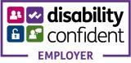 cid:image005.jpg@01D77EFE.93A73200 