

As an equal opportunities employer NPTC Group of Colleges encourages applicants from all sections of the community for the position of:

Library Officer (Brecon College)

To deliver a range of frontline library services and to assist service users to make effective use of the information and resources available to them. To provide information, advice and support for college students, staff and members of the public when accessing college services on College premises, online and in Y Gaer Cultural Hub.

Salary: Scale 3, Points 17 - 20, £22,646 - £24,387 per annum pro rata
(equivalent to £21,421 - £23,068 per annum)

Hours of Work: 35 hours per week (may include early mornings, evenings and weekends).

Contract: Part time, permanent.

Location: NPTC Group of Colleges (initially based at Brecon College).

Qualifications: The ideal candidate should hold a relevant level 3 qualification and have relevant experience. You should also hold a level 2 qualification in Maths and English (GCSE or equivalent) and be IT literate to level 2 with good knowledge of MS Office. Ideally you will hold a First Aid Certificate, although training will be provided. Experience of working in an education or library environment would be advantageous.

Closing Date: 12 Noon, Wednesday 22 March 2023.
For further details or to apply online please access www.nptcgroup.ac.uk/jobs
Alternatively, email jobs@nptcgroup.ac.uk quoting ref: 220323/LO/AH

The successful applicant will need to obtain a satisfactory
Enhanced Disclosure Check
We regret that only shortlisted applicants will be contacted. We welcome applications in Welsh and an application submitted in Welsh will not be treated less favourably than an application submitted in English.

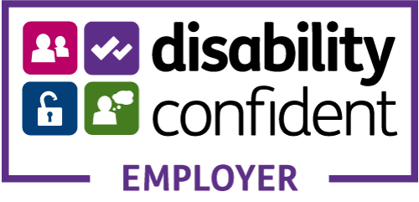

No Agencies Please

