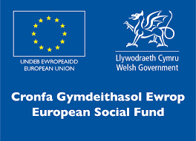


As an equal opportunities employer NPTC Group of Colleges encourages applications from all sections of the community for the position of:

Administration Assistant (Newtown College)

To carry out associated administrative procedures within the Work-Based Learning (WBL) contract and associated training.

Rate of pay: Scale 2, Points 14 – 16, £19,100 - £19,595 per annum

Hours of Work: 37 hours per week (including evening work and occasional early mornings and weekends).

Contract: Full time, permanent.

Location: NPTC Group of Colleges (initially based at Newtown College).

Qualifications: The ideal candidate should have a Level 2 qualification in relevant discipline and have relevant experience. You should also hold level 2 qualifications in English and Maths (GCSE or equivalent) and be IT literate to level 2 (with working knowledge of using MS Word and Excel). Experience and knowledge of work-based learning would be advantageous.

Closing Date: 12 Noon, Friday 19 August 2022.

For further details or to apply online please access www.nptcgroup.ac.uk .
Alternatively, email jobs@nptcgroup.ac.uk quoting ref: 190822/AA/PWT/NEW/BT

The successful applicant will need to obtain a satisfactory
Enhanced Disclosure Check.

We regret that only shortlisted applicants will be contacted.
We welcome applications in Welsh and an application submitted in Welsh will not be treated less favourably than an application submitted in English.


No Agencies Please

