His Majesty’s Inspector of Education and Training

(HMI)

**Information Pack**

*A unique role in Welsh education and training*

**Closing date: 10am on Monday, 29 January 2024**



# 

Contents

Welcome 3

A learning inspectorate: listening, learning and changing together 4

Who we are looking for 6

What your role will involve 7

Person specification 8

Additional information 11

What’s it like to be an HMI? 13

Why work for Estyn? 14

Diversity and Inclusion 14

Future opportunities 15

About us – Our work and our values 16

Benefits of joining Estyn 17

Apply now! 19

Selection process and key dates 19

Further Enquiries 21

**This document is available in Welsh on our** [**website**](https://www.estyn.llyw.cymru/gweithio-ni/gweithio-i-ni?_ga=2.174547106.1400315559.1613463765-378890110.1613463765) **or from** [**recriwtio@estyn.llyw.cymru**](mailto:recriwtio@estyn.llyw.cymru)

# Welcome

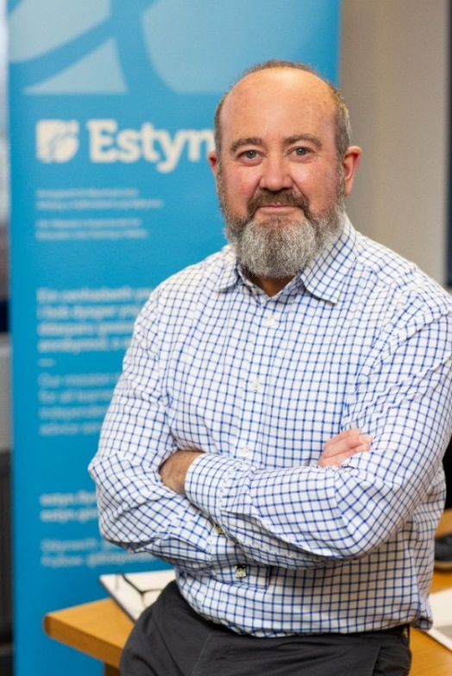

**A message from Owen Evans, His Majesty’s Chief Inspector of Education and Training in Wales**

It’s an exciting time to join Estyn. In this time of change in the Welsh education and training system, our priority is ensuring standards are excellent and supporting the education system. Over the next year we will:

* Continue developing our inspection model to provide both assurance but to also ensure that we support improvement in the sectors we inspect
* complete the inspection cycle for maintained schools and PRUs
* continue to finalise our new arrangements for inspecting from 2024
* implement new inspection arrangements across sectors from September 2024
* work with the new Commission for Tertiary Education and Research to develop our work in the post-16 sectors
* play a leading role in the development of the Welsh education and training system in collaboration with our stakeholders

I am proud to lead an organisation that has been recognised as playing a vital role in enhancing the learning of young people and adults in Wales. Learners are at the heart of everything we do. Our people are committed to working collaboratively to deliver a high quality service to our stakeholders that provides public accountability and supports improvement.

We are looking for the brightest and best leaders from all backgrounds to join us in achieving excellence for all learners in Wales. The role of a His Majesty’s Inspector (HMI) is an exciting and varied one that gives you a privileged view of education and training in Wales. Working for Estyn could be an excellent development opportunity for you. Join us and you’ll be guaranteed every day is different in this rewarding role where you’ll play a vital role in making sure inspection is a positive experience for everyone involved.

We look forward to receiving your application.

# A learning inspectorate: listening, learning and changing together

The COVID-19 pandemic has changed peoples’ lives and posed major challenges to our education system. We’re very aware of its continued effect on families, professionals and everyone involved in education and training. We’ve seen remarkable and courageous contributions from those working in education and training in Wales. There’s been an enormous effort to revitalise the experience of learners and education providers are working hard to minimise the pandemic’s impact on children, young people and learners of all ages.

In 2022, we returned to on-site inspection and we have increased the rate of core inspection to complete the cycle for inspections. We made some significant changes to our inspection arrangements to lower the stakes of inspection and drive more improvement. These include the removal of summative grading and an increased role for the nominee. We’re committed to making our work a positive experience and having more impact through our work.

**Supporting renewal and reform:** We’ll make sure that Estyn’s voice and experience is felt across a range of developments to the Welsh education sector. We established a framework of activity that aligns with the changes to education and training in Wales and continue to be sensitive to the challenges facing education and training providers and their communities.

We will:

further develop our role as a key source of expertise, fresh thinking and effective practice in the field of education and training policy

continue to focus on support, particularly on key themes, including rolling out the new curriculum and additional learning needs reform

work with the Welsh Government, the new Commission for Tertiary Education and Research and our stakeholders to support post-compulsory education and training reform

pilot our new 2024 inspection arrangements in preparation for roll-out in September 2024

continue joint inspections of non-maintained provision with Care Inspectorate Wales

continue to monitor schools causing concern

continue with our range of work to support the ongoing registration of independent schools

continue with our programme of thematic work and sharing insights and examples of good practice we see across Wales

build on our excellent joint working and cooperation with inspectorates in Wales, the UK and further afield

* start our inspection cycle of youth work providers

**2024 and beyond** -Inspection will always bring a vital, independent perspective to assuring the quality and standards in schools and other providers. But as the changes in education and training in Wales evolve and providers mature in their approach to improvement, we have adapted our arrangements from September 2024 to complement the national approach to evaluation and improvement that:

are more frequent

align with and continue to support the implementation of Curriculum for Wales

put sustained improvement at the core of the education and training system

With the post-16 education and training reforms through the establishment of the Commission for Tertiary Education and Research, we will be evolving and developing our inspection arrangements with our post-16 stakeholders.

Want to know more? Visit: <https://www.estyn.gov.wales/about-us>

# Who we are looking for

Our HMI come from a diverse range of leadership backgrounds in education and training. You may for example, be:

* the headteacher of a primary school or primary phase leader in an all-age school
* a senior leader in a secondary school or secondary phase leader in an all-age school
* a senior leader in a mainstream independent school
* a senior leader or a quality manager in a further education college
* a youth service manager or leader elsewhere with a background in youth work

Whatever path your career has taken so far, you will have a strong track record of improvement with experience of innovating at a strategic level. You will also understand the wider education and training landscape and the role that inspection plays as a force for improvement.

For this recruitment we are looking for people with a background in:

* Primary education
* Secondary education
* Mainstream independent schools
* Post-16 (further education)
* Youth work
* Local government education services

For a number of these posts, Welsh language skills are **desirable**.

Except for the Post-16 and youth work roles, **qualified teacher status (QTS)** is an **essential** requirement for all posts.

# What your role will involve

You will be responsible for reporting on the standards and quality of education and training in providers across Wales. You will contribute to the development and dissemination of effective practice and building capacity for improvement in the education and training system in Wales.

It’s a unique opportunity to experience and absorb practice in a large number and variety of providers and other educational settings; their ethos, character and approach to curriculum and innovation. Where providers are struggling, you will develop a keen insight into challenges and how improvements can be made.

Much of your work will be on-site in different settings, so you need to be willing to undertake significant travel across Wales and frequently stay overnight in hotels. Whenever possible, you will be allocated inspections close to home. Working from home between inspections, you will find a valuable work/life balance.

No two days will ever be the same. They could include anything from:

* talking to learners about their work
* visiting lessons
* talking to parents about their child’s education provider
* speaking with teachers and leaders
* In post-16, observing learning and talking to learners, staff and leaders.
* engaging with young people in informal settings (youth work)

Acting as both a lead inspector and contributing to work across a range of sectors, you will develop a critical understanding of each provider, objectively reporting on standards and effectiveness. You will make judgements on the effectiveness of leadership in each provider, including how well learners are kept safe.

Putting the best interests of learners above all else, you will ensure that your judgements are fair and evidence-based. Sharing your evolving knowledge and expertise with colleagues, you will also prepare and deliver training for external Estyn Inspectors.

You will be a role model for our values, always acting in the interest of children and learners and promote and safeguard the welfare of children, young people and vulnerable adults you come into contact with.

Much of your work will see you directly interacting with providers, but the role will also require you to balance various additional challenges, like:

* contributing to national developments through the provision of professional advice and thematic work
* engaging with external stakeholders
* quality assurance of inspection reports and thematic work
* contributing to organisational development and change

We will give you all the support you need to excel in the role and develop new skills.

# Person specification

The table below provides further details about the essential and desirable criteria and how these will be tested throughout the selection process.

| **Essential Requirements** | **Tested by** |
| --- | --- |
| **Qualifications** | |
| * Degree level qualification or equivalent. * Must hold a recognised teaching qualification which has resulted in Qualified Teacher Status (QTS) - all posts other than post-16 (further education) and youth work * Appropriate level of qualification for full registration with the Education Workforce Council | Application form  Application form |
| **Experience** | |
| * A minimum of three years leadership or specialist experience at a senior level in one or more of the sectors we inspect with a particular focus on primary education, secondary education, mainstream independent schools, further education colleges, youth work or local government education services. * A proven track record of achieving improved outcomes and experiences for learners | Application form  Assessment  Interview  Application form  Assessment  Interview |
| **Technical** | |
| * An awareness of the current changes taking place in education and inspection and the ability to keep up to date across a wide range of professional matters * A deep and broad knowledge and understanding of current education and training issues gained in one or more of the sectors we inspect * An understanding of the key stakeholders in education and training, and their operational context * Analyses and interprets data and evidence to support lines of enquiry and support judgements | Application form  Assessment  Interview  Interview  Assessment  Interview  Assessment |
| **Ability** | |
| * Able to communicate clearly and effectively both verbally and in writing demonstrating clarity and influence * Able to use IT equipment effectively in your daily work | Application form  Assessment  Interview  Application form  Assessment |
| **Behaviour – Leadership** | |
| * Inspire and motivate others to be fully engaged in their work and dedicated to their role * Stands by own and team’s actions and decisions where needed and challenges effectively holding others to account * Welcomes and responds to views and challenges from others, despite any conflicting pressures * Promote diversity, inclusion and equality of opportunity, respecting difference | Application form  Assessment  Interview |
| **Behaviour – Communicating and Influencing** | |
| * Engage in constructive professional dialogue with colleagues and key stakeholders, building effective partnerships and trust * Explain complex issues in a way that is easy to understand and is appropriate to the audience * Deliver difficult messages with clarity and sensitivity and considers the impact of the language used * Remain open minded and impartial while respecting the diverse interests and opinions of others | Application form  Assessment  Interview |
| **Behaviour – Making effective decisions** | |
| * Make sound judgements and reliable decisions in a variety of demanding and time-pressured situations * Clarify own understanding before making decisions and encourage innovative suggestions and challenge from others to inform decision making * Analyse and accurately interpret data from various sources to support decisions * Present reasonable conclusions from a wide range of complex evidence * Make decisions confidently even when details are unclear or if they prove to be unpopular | Application form  Assessment  Interview |
| **Behaviour – Delivering at pace** | |
| * Manage competing priorities effectively and ensures the timely delivery of quality outcomes * Complies with legal and regulatory requirements * Demonstrate resilience and maintains own levels of performance in challenging circumstances and encourages others to do the same * Ensure everyone clearly understands and owns their roles and responsibilities | Application form  Assessment  Interview |
| **Desirable Requirements** | **Tested by** |
| **Technical** | |
| * Successfully completed training as an Inspector of Education and Training (Registered Inspector, Additional Inspector or Peer Inspector) | Application form |
| **Ability** | |
| * Able to communicate effectively through the medium of Welsh | Application form  Assessment  Interview |

# Additional information

**Job Title:** His Majesty’s Inspector of Education and Training (HMI) (Grade 6)

**Salary****:** £70,455 - £82,425 (full time equivalent). Please note, starting salary will normally be offered first scale point above your current salary (within this range), and will be pro rated based on your working hours.

**Duration:** Permanent

**Welsh Language:** We work in both Welsh and English and many of our stakeholders are bilingual. For a number of these posts Welsh language skills are **desirable**.

**Safeguarding -** We are committed to safeguarding and promoting the welfare of children and young people and expect all our people to share this commitment. The role of HMI requires an enhanced disclosure check via the Disclosure and Barring Service (DBS). The role will bring you into direct contact with children or vulnerable adults and give you access to material or sensitive information about children and vulnerable adults. You will be expected to have an awareness of and the ability to comply with policies and procedures relating to:

* safeguarding
* child protection
* health, safety and security
* confidentiality
* data protection

**Orders in Council -** If your application is successful, Orders in Council will need to be obtained from the Privy Council before you can be confirmed as an His Majesty’s Inspector. You will be appointed as an HMI designate until Privy Council approval is obtained.

**Location -** We are based in Cardiff and our Inspectors are home-based. Our work is predominantly undertaken within Wales. On appointment, depending on the location of your home-base we may allocate you to a notional location for travel and subsistence and/or offer you financial assistance for relocation. You should check this before committing yourself to any expenses. If payment is made, it will be made after you have started work and you must agree to repay a proportion if you resign within a specified period. This role can only be worked in the UK and not overseas.

**Driving licence and use of a car -** Due to the requirement for frequent travel across Wales, you should have a current driving licence and the use of a car or the ability to make suitable alternative transport arrangements.

**Work hours -** Our normal work hours are 37 hours over a five day week (Monday to Friday), excluding lunch. This role requires frequent travel all over Wales and a regular need to be able to stay away from home for up to four nights at a time.

We welcome applications for part-time/reduced hours, job sharing or on another flexible basis. If you’d like to apply to work flexibly, please include a statement in your application outlining the flexibility/preferred pattern you’d like us to consider and the reasons for your request. We will consider your request and our operational requirements in line with our [Flexible Working Policy](https://www.estyn.gov.wales/system/files/2020-07/Flexible%2520working%2520policy_0.pdf).

**Nationality -** To be eligible for these roles you must meet the nationality requirements set out in the [Guidance for Applicants](https://www.estyn.gov.wales/working-us/current-vacancies?_ga=2.10216181.1705140105.1612862263-1615018.1612862263).

# What’s it like to be an HMI?

In the following film and profiles you’ll meet some of our current HMI who will share their experiences with you about what it’s like to be an HMI and the aspects of the role they find rewarding and challenging. Click play on the videos to hear from a number of our HMI.

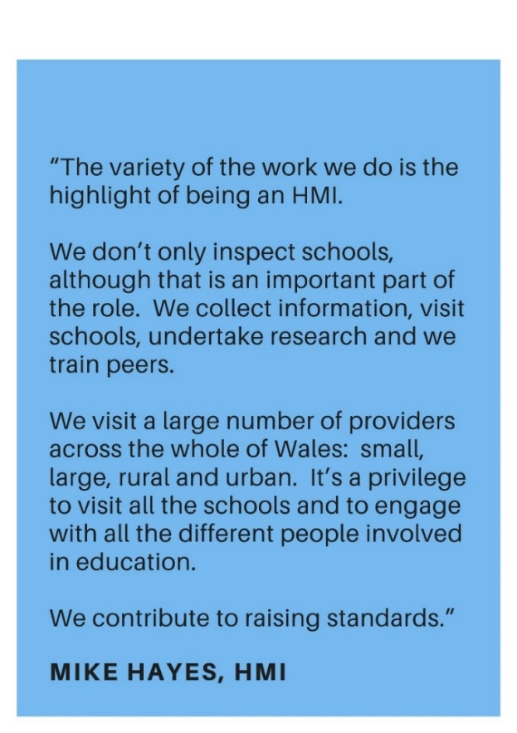[](https://www.youtube.com/embed/mbGyTDGD2to?feature=oembed)[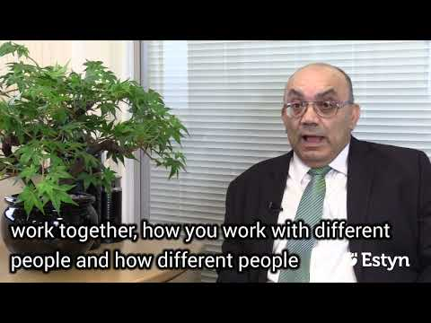](https://www.youtube.com/embed/A2vLpHpJRy8?feature=oembed)[](https://www.youtube.com/embed/1MsWiYGmjg8?feature=oembed)[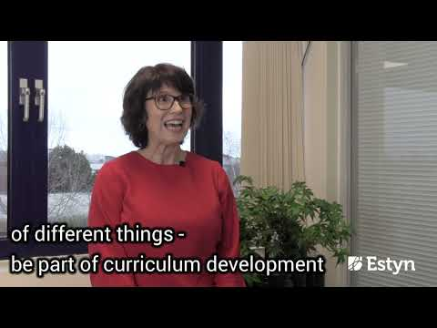](https://www.youtube.com/embed/wvzmY00kj0I?feature=oembed)[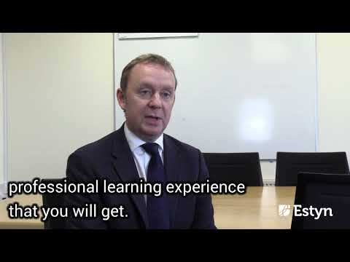](https://www.youtube.com/embed/gF00VzhGPzk?feature=oembed)

# Why work for Estyn?

It’s a great place to work and our people are our most valuable resource. Our people are highly engaged in our work and our People Survey results are consistently among the best in the Civil Service.

We value, listen to, and encourage our people to develop their skills and talents. As one of our inspectors, you’ll have access to learning and development opportunities that will help you to develop valuable skills to help further your career. These include individual, team, professional and organisational learning, and continuous development.

Working from home in-between inspection and face-to-face meetings, you will benefit from the freedom and flexibility that comes with working independently, while supported by a broad network of colleagues who share your passion for education and learning. You may be required to work outside of normal hours, depending upon the provision or service being inspected.

Each HMI is allocated to a sector team and is supported by an Assistant Director and a peer mentor during your first year. After a comprehensive induction and learning period you will be in regular contact with colleagues within your sector and across other sectors, providing advice and support.

# Diversity and Inclusion

We’re committed to supporting diversity and inclusion – involving all, valuing, respecting and positively welcoming the challenges of diverse ideas, views and lived experiences. We want to reflect the communities we serve and improve decision making.

We recognise that everyone brings different skills and experience to our organisation, and that this diversity is what makes a strong organisation. We encourage applications from the widest possible diversity of backgrounds, cultures and experiences. We particularly welcome applications from people with an ethnic minority background, as well as people living with a disability.

# Future opportunities

With ongoing training, you will develop valuable skills and have the opportunity to:

* become a sector lead inspector or lead officer for a specific area of work
* get involved in training external Estyn Inspectors
* contribute to the development of inspection arrangements and materials
* thematic research work and projects
* become an Assistant Director

# About us – Our work and our values

We are the education and training inspectorate for Wales. Our aim is to improve the quality of education and training for learners in Wales. One of our key roles is to inspect education and training in Wales to give assurance to the public and government regarding educational standards. We help education providers, such as schools and colleges, to improve quality and outcomes. We also advise the Welsh Government about educational policy and prepare reports on a wide range of educational issues and themes.

Our [Annual Plan](https://www.estyn.gov.wales/publications-and-policies/corporate-publications) sets out our key activities for the year. Find out more about our work on our website: [www.estyn.gov.wales/about-us](http://www.estyn.gov.wales/about-us).

As Civil Servants, we model the values, behaviours and standards set out in the [Civil Service Code](https://www.gov.uk/government/publications/civil-service-code/the-civil-service-code).



1 Our ‘leadership statement’ in our [Annual Plan](https://www.estyn.gov.wales/about-us/corporate-publications-accounts) sets out the expected behaviours and the approach to leadership that we expect from all our staff.

2 The [Civil Service Code](https://www.gov.uk/government/publications/civil-service-code/the-civil-service-code) sets out the Civil Service values, standards of behaviour, and rights and responsibilities.

# Benefits of joining Estyn

In addition to a good work/life balance, job satisfaction, a supporting culture, ongoing learning and development opportunities and professional development, you can also expect other benefits, including the following:

|  |  |
| --- | --- |
|  | **Competitive salary** - The salary range is £70,455 - £82,425. Starting salary will normally be the first scale point above your current salary (within this range).. With incremental progression you will normally reach the maximum of the pay scale within three years of joining |
|  | **Paid travel and expenses** – Central booking service for travel and overnight stays (paid directly by Estyn). Mileage and car-parking fees reimbursed. Meal and refreshments allowance for overnight stays |
|  | **Excellent pension** – Choose from a defined benefit pension scheme with Estyn contributing up to 27.9% of your salary or a defined contribution arrangement. We are part of the *Civil Service Pension Scheme*. If you’re already in a Pension Scheme you can freeze this or transfer it into the *Civil Service Pension Scheme*. Find out more details on[Joining the Pension Scheme - Civil Service Pension Scheme](https://www.civilservicepensionscheme.org.uk/joining-the-pension-scheme/) |
|
|  | **Generous holiday entitlement** – 31 days of annual leave, plus 10 public/privilege holidays each year. Annual leave is pro-rated for those who work part-time. Further paid / unpaid leave options available to help combine work with other life commitments and responsibilities (e.g. career break, compassionate leave, fostering to adopt etc) subject to business needs |
|  | **Support for your wellbeing** – We are committed to supporting high levels of positive wellbeing. We provide an employee assistance programme (EAP) offering access to 24/7 confidential advice and support, including access to emotional support counselling and specialist advisors. We offer a free annual health check, trained mental health first aiders, a free eye care scheme and subsidised seasonal flu jabs. We’ve achieved the Silver Award for the Corporate Health Standard for our health and wellbeing support. We also provide access to Health Insurance Plans through Civil Service Healthcare. We also provide employees with regular wellbeing time across the year. |
|  | **Diversity and inclusion** – We want to maximise the potential of everyone who works for us, regardless of their background. We’ve created a working environment that is welcoming, respectful, and engaging for everyone, with opportunities for personal and professional development |
|  | **Support for your family life** – generous maternity, paternity, adoption, shared parental and parental leave provisions and flexible working, including job share opportunities. |
|  | **Tax-free savings** – Access to a cycle to work scheme. |
|  | **Modern equipment** – home office facilities, such as a laptop, printer, mobile phone. We will also provide you with a desk, chair and filing cabinet |
|  | **Additional financial support** – including interest-free salary advance for travel season tickets and a working from home allowance of £450 a year |
|  | **Special offers and discounts** – Access to a range of discounts and exclusive offers for many high street shops, cinemas, supermarkets, holidays, restaurants, gyms and family attractions through the *Civil Service Social Club – Sports and Leisure*. Access to further benefits and services including the *Civil Service Motoring Association*, the *Civil Service Insurance Society* and the *Charity for Civil Servants* |

For more information, visit our website: [www.estyn.gov.wales/about-us#workingforus](https://www.estyn.gov.wales/about-us#workingforus)

# Apply now!

**Application form:** Download and complete our application form here: [www.estyn.gov.wales/working-us/current-vacancies](https://www.estyn.gov.wales/working-us/current-vacancies)

**Closing date: 10am** on **Monday, 29 January 2024**

Send your application to: [**recruitment@estyn.gov.wales**](mailto:recruitment@estyn.gov.wales)

We are unable to consider late or incomplete applications. It’s your responsibility to ensure that your application is fully completed and is received by the closing date.

We recommend emailing your application. We are currently experiencing delays in receiving post that may mean your application is late. If you’re unable to send your application electronically, please contact Rachel Hall on 029 2044 6336.

**Alternative arrangements or accessible documents**: If you’d like to apply or access this document in an alternative format, please contact Rachel Hall on 029 2044 6336 to discuss your requirements.

This recruitment exercise is conducted in accordance with the Civil Service Commission [Recruitment Principles](https://civilservicecommission.independent.gov.uk/recruitment/recruitment-principles/) and is regulated by the Civil Service Commission.

# Selection process and key dates

As part of the selection process, you will be asked to complete an application form detailing your job history and qualifications and answer three questions (within a specified word count) to evidence how you meet the essential skills, experience and behaviours for this role outlined in the person specification. These will also be explored at assessment and interview.

You can find more guidance on completing your application here: [www.estyn.gov.wales/working-us/current-vacancies](http://www.estyn.gov.wales/working-us/current-vacancies)

All documents are available in Welsh and English. Applications can be submitted in Welsh, English or both languages.An application submitted in Welsh will not be treated less favourably than an application submitted in English. Your application may be translated into Welsh or English if required (depending on the majority language of the panel).

The selection process includes:

* **Initial sift of applications:** The selection board will consider all complete applications. The information you give us in your application is important in deciding whether we will invite you to the next selection stage. If we receive a high volume of applications, your application may be “long-listed” before it is passed to the panel for consideration. You should be aware that in this situation, your application might not be considered in full by all of the panel. We will create a long-list from the sift of applications who will be invited to the assessment stage.
* **Assessment:** You will be asked to complete a series of tasks as part of a work-based written exercise (or other details as required). Further details will be given in the invite to assessment. For Welsh essential posts, we will test your communication skills in both Welsh and English during the assessment.
* **Short-listing:** The selection board will consider the assessment scores and create a short-list to invite to interview.
* **Interview:** We use a blended interview technique, allowing us to find out more about you. We use the [Success Profiles framework](https://www.gov.uk/government/publications/success-profiles). During the panel interview, you will be asked about your skills and experience and how you meet the criteria for the role (including behaviours). The interview will include a short presentation. Further details will be given in the invite to interview. For Welsh essential posts, we will test your communication skills in both Welsh and English during the interview.

Interviews will be held face to face in our Cardiff office. We will confirm the arrangements when we invite you to interview. All costs of attending the assessments and interviews are at your own expense. We will not pay any transport, accommodation or subsistence costs related to the recruitment.

You will receive an email confirming the outcome of your application at each selection stage. We appreciate it takes a lot of time and effort to apply for roles and that feedback is a valuable part of the process. We will provide verbal feedback on request for anyone reaching the assessment and interview stages once the selection process has finished.

The timetable we’re working to is summarised below. If you’re successful at the shortlisting stage, you will be expected to make yourself available for assessment and on the interview dates. Applicants who are not available to attend for assessment and interview on the dates offered may not be considered for this role.

If you’re unable to make the arranged assessment and interview dates, we will try to re-arrange it but it might not be possible due to time constraints within the appointment timetable or selection panel availability.

|  |  |
| --- | --- |
| **Closing date** | 10:00am Monday, 29 January 2024 |
| **Initial Sift** | 6 February 2024 |
| **Assessments** | Week starting 19 February 2024 |
| **Shortlisting** | 28 February 2024 |
| **Interviews** | Week starting 11 March 2024 |
| **Appointment starts** | September 2024 |

*Dates may be subject to change

**Future vacancies and reserve lists :**  If you are appointable, but there isn’t a suitable post immediately available, we may add you to a reserve list. The reserve list is valid for up to twelve months from the date we confirm the outcome of your application. The outcome email will confirm if you are on a reserve list. If a suitable vacancy occurs during that period, we may recommend you for appointment. We appoint from the reserve list in merit order.

# Further Enquiries

If you have any questions about this recruitment exercise that we haven’t answered in this pack, please contact Rachel Hall on 029 2044 6336, or [recruitment@estyn.gov.wales](mailto:recruitment@estyn.gov.wales)

We welcome correspondence in Welsh; we’ll respond to you in Welsh, and there won’t be a delay in our response.