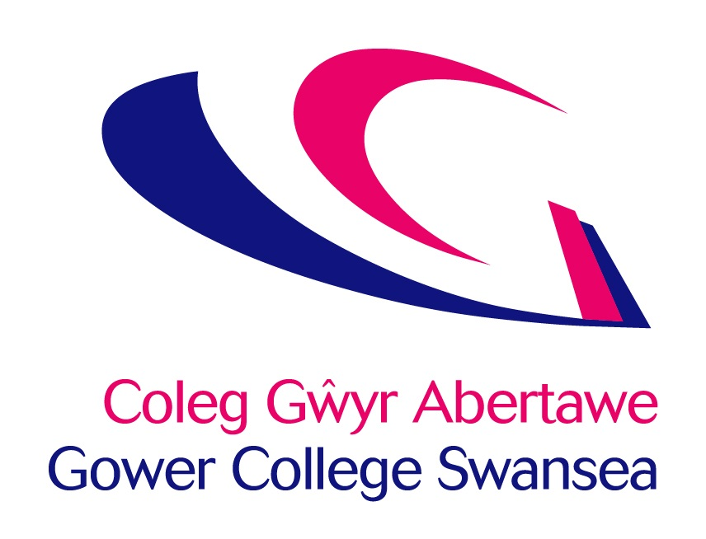
Job Description
Post: | Individual Development Plan (IDP) Administrator
Accountable to: | Learning Area Manager – ILS & College lead for ALN
Department: | Additional Learning Needs (ALN)

Job Focus:
To coordinate the management of Person-Centred Reviews in the Independent Living Skills (ILS) and mainstream settings. To inform, create and maintain learners Individual Development Plans in line with the Additional Learning Needs Educational Tribunal (ALNET) Act. To work with key external stakeholders, learners and staff within the college to ensure that all IDP’s are completed within the timescales set and ensuring that relevant parties are kept up to date with developments. To ensure that the college vision and commitment to learner experience is delivered effectively through meeting targets in order to maximise benefits to learners and help them to achieve their full potential.

Key Accountabilities:

- Monitor, maintain and manage records on all learners with an IDP and ensure targets for review dates are met.

- Be responsible for organising and/or coordinating attendance to Person Centred Review meetings to inform the creation, maintenance, or ceasing of a young person’s Individual Development Plans (IDP) in line with the ALN Code 2021.

- Recording of minutes at PCR meetings and update IDPs on an annual basis.

- To create and/or maintain IDPs ensuring that the learner voice is at the centre of all decision-making processes.

- Provide advice and guidance to staff to improve the quality of the IDPs.

- Moderate IDPs to ensure there is consistency throughout the college.

- Deliver training so we remain compliant with the ALNET Act and the Equality Act legislation.

- Support the Transition and Review Officers with data/information gathering on prospective students.

- To undertake any other reasonable duties as requested by Additional Learning Needs Manager.

- To keep up to date with legislation that has relevance to learners with difficulties and/or disabilities within a Post 16 setting.

- To carry out administrative duties with in the ALN department.

Other Tasks

- Comply with all College Policies & Procedures, keeping abreast of any changes and updating practice and/or systems to ensure continued compliance.
- Ensure that all aspects of the College Financial Regulations are followed.
- Contribute to and represent the overall vision and values of the College.
- Ensure that all services are delivered in compliance with the Welsh Language Standards.
- To flexibly respond to the needs of the business and to provide an effective service to our learners and other stakeholders.

Personal Development

In partnership with the College, take responsibility for personal development, including:
1. Participating in an annual staff review and identifying development needs.
2. Updating of professional, teaching and training skills and qualifications, through attending staff development opportunities, joining professional bodies and keeping informed of educational and professional initiatives.

Health & Safety

All employees have a statutory duty of care for their own personal safety and that of others who may be affected by their acts or omissions. Staff are required to co-operate with management to enable the College to meet its own legal duties and to report any hazardous situations or defective equipment.

General

This description is not intended to establish a total definition of the job, but an outline of the responsibilities you are expected to undertake. From time to time you may be required to undertake any other duties commensurate with your level of responsibility.

This is a description of the job as it is at present constituted. It is the practice of the College periodically to examine employees’ job descriptions and to update them to ensure that they relate to the job as then being performed, or to incorporate whatever changes are being proposed. You will, therefore, be expected to participate in any discussions relating to Job Description change.
Person Specification – Individual Development Plan Support and Administrative Support

In your application you are asked to address only those criteria labelled A. These will be used to shortlist applicants. Criteria labelled I will be explored at interview and those labelled WRE in assessment centre activities.

Criteria | Essential Criteria | Desirable Criteria | Method
Qualifications: | Four GCSEs, including Maths and English at Grade C or above or equivalent  Extensive training in the area of Additional Learning Needs and/or inclusive practice in education | Higher level qualification (Level 5 – 7) relevant to Additional Learning Needs / Special Educational Needs / Inclusion | A  A  A
Knowledge & Experience | Detailed knowledge of ALNET and the Equality Act and the implications to providing support to young people in college  Good understanding of the complex needs and barriers to learning faced by learners with ALN | Experience of attending and contributing to annual reviews | A/I  A/I  A  A
Skills & Abilities: | Demonstrate a professional attitude, diplomacy and an ability to manage difficult situations  Able to deliver presentations/training groups of people with confidence and enthusiasm  Able to respond positively, learn and adapt quickly to new situations and requirements  Good oral and written skills  Competent using a wide range of IT including Word, Excel and Outlook as well as having knowledge of accessibility tools available |  | I  I  I  A/I  A/I
Personal Attributes: | Ability to maintain effectiveness in a pressurised environment |  | I
Special  Requirements: | A flexible approach to working hours which may include work at evenings and weekends.  Ability to travel cross campus and to partnership schools / local authorities. |  | I  I

A – Application Form
I – Interview
WRE – Work Related Exercise

WELSH LANGUAGE LEVEL DESCRIPTORS
DISGRIFYDD LEFEL IAITH GYMRAEG

Welsh Essential | LEVELS | Listening | Speaking | Writing | Reading
Welsh Essential | Level 4  Proficient | Able to understand all conversations involving work | Fluent – able to conduct a conversation and answer questions, for an extended period of time where necessary | Skilled – able to complete complex written work without the need for revision | Able to understand all material involving work
Welsh Essential | Level 3  High | Able to follow the majority of conversations involving work including group discussions | Able to speak the language in the majority of situations using some English words | Able to prepare the majority of written material related to the area, with some assistance in terms of revision | Able to read the majority of material in own area
Welsh Essential | Level 2  Intermediate | Able to follow routine conversations involving work between fluent Welsh speakers | Able to converse with someone else, with hesitancy, regarding routine work issues | Able to draft routine text, with editing assistance | Able to read routine material with a dictionary
Welsh Essential | Level 1  Foundation | Able to understand a basic social conversation in Welsh | Able to answer simple enquiries involving work | Able to answer simple correspondence with assistance | Able to read basic material involving work (slowly) and understand text that consist mainly of high frequency everyday work related language
Welsh Desirable | Entry | Able to understand basic enquiries in Welsh (“Ble mae…? Ga’ i siarad â…?”) | Able to conduct a general conversation (greetings, names, sayings, place names) | Able to write basic messages (“Diolch am dy help.”) | Able to understand and read very short, simple texts
Welsh Desirable | None | No Welsh language skills at all | No Welsh language skills at all | No Welsh language skills at all | No Welsh language skills at all

DISGRIFYDD LEFEL IAITH GYMRAEG
WELSH LANGUAGE LEVEL DESCRIPTORS

Cymraeg Hanfodol | LEFEL | Gwrando | Siarad | Ysgrifennu | Darllen
Cymraeg Hanfodol | Lefel 4  Rhugl | Gallu deall pob sgwrs yn ymwneud a’r gwaith | Rhugl – gallu cynnal sgwrs a gofyn cwestiynau, am gyfnod estynedig pan fod angen | Medrus – gallu cwblhau gwaith ysgrifenedig cymhleth heb angen adolygu | Gallu deall deunyddiau yn ymwneud a’r gwaith
Cymraeg Hanfodol | Lefel 3  Uchel | Gallu dilyn y mwyafrif o sgyrsiau yn ymwneud a’r gwaith yn cynnwys trafodaethau grwp | Gallu siarad yr iaith yn y mwyafrif o sefyllfaoedd gan ddefnyddio rhai geiriau Saesneg | Gallu paratoi'r mwyafrif o waith ysgrifenedig yn ymwneud a’r maes, gyda pheth cymorth o ran adolygu | Gallu darllen y mwyafrif o ddeunyddiau yn fy maes
Cymraeg Hanfodol | Lefel 2  Canolradd | Gallu dilyn sgyrsiau arferol yn ymwneud a gwaith, rhwng siaradwyr Cymraeg rhugl | Gallu sgwrsio gyda rhywun arall am faterion gwaith arferol, ond yn petruso | Gallu drafftio testun arferol, gyda chymorth golygu | Gallu darllen deunyddiau arferol gyda geiriadur
Cymraeg Hanfodol | Lefel 1  Sylfaen | Gallu deall sgwrs gymdeithasol sylfaenol yn Gymraeg | Gallu ateb cwestiynau sylfaenol yn ymwneud a’r gwaith | Gallu ateb gohebiaeth gyda chymorth | Gallu darllen deunyddiau syml yn ymwneud a gwaith (yn araf) a gallu deall testun sy’n cynnwys iaith gwaith pob dydd yn bennaf
Cymraeg Dymunol | Mynediad | Gallu deall ymholiadau sylfaenol yn Gymraeg (“Ble mae…? Ga’ i siarad â…?”) | Gallu cynnal sgwrs gyffredinol (cyfarchion, enwau, dywediadau, enwau llefydd) | Gallu ysgriffennu negeseuon sylfaenol (“Diolch am dy help.”) | Gallu deall a darllen testunau byr, syml iawn
Cymraeg Dymunol | Dim | Dim sgiliau Cymraeg o gwbl | Dim sgiliau Cymraeg o gwbl | Dim sgiliau Cymraeg o gwbl | Dim sgiliau Cymraeg o gwbl

