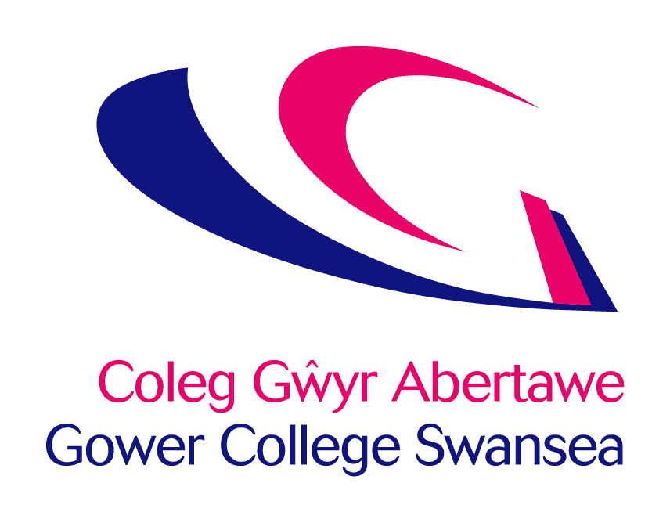
Job Description
Post: | Football Coach: Goalkeeper
Accountable to: | Learning Area Manager Sport and Protective Services
Department: | Sports and Protective Services

Job Purpose

To support student college sports enrichment opportunities within the Football Academy pathway through providing high quality coaching and performer support.

Key Responsibilities

- Plan, deliver and evaluate tailored sessions that are appropriate to the needs of the athletes with the GCS Football Academy.
- Assist in the recruitment process of new high performance athletics into GCS Sports Academies.
- Working as part of a multi-disciplinary team delivering services to athletes, clubs and coaches.
- Where appropriate use video analysis to provide feedback to athletes.
- Monitor the attendance of the sports club at team training sessions.
- Any other duties as may reasonably be required, consistent with the grade of the post.

Other Tasks

- Comply with all College Policies & Procedures, keeping abreast of any changes and updating practice and/or systems to ensure continued compliance.

- Ensure that all aspects of the College Financial Regulations are followed.

- Contribute to and represent the overall vision and values of the College.

- Ensure that all services are delivered in compliance with the Welsh Language Standards.

- To flexibly respond to the needs of the business and to provide an effective service to our learners and other stakeholders.

PERSONAL DEVELOPMENT

In partnership with the College, take responsibility for personal development, including:
1. Participating in an annual staff review and identifying development needs.
2. Updating of professional, teaching and training skills and qualifications, through attending staff development opportunities, joining professional bodies and keeping informed of educational and professional initiatives.

HEALTH & SAFETY
All employees have a statutory duty of care for their own personal safety and that of others who may be affected by their acts or omissions. Staff are required to co-operate with management to enable the College to meet its own legal duties and to report any hazardous situations or defective equipment.

GENERAL
This description is not intended to establish a total definition of the job, but an outline of the responsibilities you are expected to undertake. From time to time you may be required to undertake any other duties commensurate with your level of responsibility.

This is a description of the job as it is at present constituted. It is the practice of the College periodically to examine employees’ job descriptions and to update them to ensure that they relate to the job as then being performed, or to incorporate whatever changes are being proposed. You will, therefore, be expected to participate in any discussions relating to Job Description change.

Person Specification – Football Coach: Goalkeeper

The Person Specification identifies essential criteria needed for the job.
The criteria are job-related, justifiable and non-discriminatory.
In your application you are asked to address only those criteria labelled A.
These will be used to shortlist applicants.

Criteria | Essential | Desirable | Method
Qualifications | - Hold a minimum of a UEFA B License Coaching Goalkeepers. |  | A
Knowledge and  Experience | - Experience of coaching in the relevant sport or activity  - Proficient knowledge and understanding of the process involved in the development of athletes/players.  - Knowledge of the basic principles of sports development.  - Experience in sports conditioning.  - Experience of long term Athlete Development.  - Understanding the structure of student sport.  - Understanding of video analysis. |  | A  A/I  A/I  A  A  A/I  A/I
Skills and  Abilities | - Ability to demonstrate a commitment to proving excellent customer service.  - Excellent communication and interpersonal skills, with the ability to motivate, enthuse, persuade, negotiate and influence others.  - Experience of using Microsoft Office. |  | A/I  A/I  A/I
Personal Attributes | - Ability to work effectively as part of a team.  - Excellent interpersonal and organisational skills.  - A positive and proactive approach to work with the ability to problem solve effectively.  - Ability to work under pressure during unexpected and challenging situations  - Enthusiasm for sport and physical activity |  | I  I  I  I  I
Special  Requirements | - Able to travel between College campuses.  - Flexibility of work hours, willing to work evenings and weekends and across campuses as and when required. | Welsh language skills – Level 2 (See detailed language level descriptors attached). | A  A

A – Application Form
I – Interview
WRE – Work Related Exercise

DISGRIFYDD LEFEL IAITH GYMRAEG
WELSH LANGUAGE LEVEL DESCRIPTORS

Welsh Essential | LEVEL | Listening | Speaking | Writing | Reading
Welsh Essential | Level 4  Proficient | Able to understand all conversations involving work | Fluent – able to conduct a conversation and answer questions, for an extended period of time where necessary | Skilled – able to complete complex written work without the need for revision | Able to understand all material involving work
Welsh Essential | Level 3  High | Able to follow the majority of conversations involving work including group discussions | Able to speak the language in the majority of situations using some English words | Able to prepare the majority of written material related to the area, with some assistance in terms of revision | Able to read the majority of material in own area
Welsh Essential | Level 2  Intermediate | Able to follow routine conversations involving work between fluent Welsh speakers | Able to converse with someone else, with hesitancy, regarding routine work issues | Able to draft routine text, with editing assistance | Able to read routine material with a dictionary
Welsh Essential | Level 1  Foundation | Able to understand a basic social conversation in Welsh | Able to answer simple enquiries involving work | Able to answer simple correspondence with assistance | Able to read basic material involving work (slowly) and understand text that consist mainly of high frequency everyday work related language
Welsh Desirable | Entry | Able to understand basic enquiries in Welsh (“Ble mae…? Ga’ i siarad â…?”) | Able to conduct a general conversation (greetings, names, sayings, place names) | Able to write basic messages (“Diolch am dy help.”) | Able to understand and read very short, simple texts
Welsh Desirable | None | No Welsh language skills at all | No Welsh language skills at all | No Welsh language skills at all | No Welsh language skills at all

DISGRIFYDD LEFEL IAITH GYMRAEG
WELSH LANGUAGE LEVEL DESCRIPTORS

Cymraeg Hanfodol | LEFEL | Gwrando | Siarad | Ysgrifennu | Darllen
Cymraeg Hanfodol | Lefel 4  Rhugl | Gallu deall pob sgwrs yn ymwneud a’r gwaith | Rhugl – gallu cynnal sgwrs a gofyn cwestiynau, am gyfnod estynedig pan fod angen | Medrus – gallu cwblhau gwaith ysgrifenedig cymhleth heb angen adolygu | Gallu deall deunyddiau yn ymwneud a’r gwaith
Cymraeg Hanfodol | Lefel 3  Uchel | Gallu dilyn y mwyafrif o sgyrsiau yn ymwneud a’r gwaith yn cynnwys trafodaethau grwp | Gallu siarad yr iaith yn y mwyafrif o sefyllfaoedd gan ddefnyddio rhai geiriau Saesneg | Gallu paratoi'r mwyafrif o waith ysgrifenedig yn ymwneud a’r maes, gyda pheth cymorth o ran adolygu | Gallu darllen y mwyafrif o ddeunyddiau yn fy maes
Cymraeg Hanfodol | Lefel 2  Canolradd | Gallu dilyn sgyrsiau arferol yn ymwneud a gwaith, rhwng siaradwyr Cymraeg rhugl | Gallu sgwrsio gyda rhywun arall am faterion gwaith arferol, ond yn petruso | Gallu drafftio testun arferol, gyda chymorth golygu | Gallu darllen deunyddiau arferol gyda geiriadur
Cymraeg Hanfodol | Lefel 1  Sylfaen | Gallu deall sgwrs gymdeithasol sylfaenol yn Gymraeg | Gallu ateb cwestiynau sylfaenol yn ymwneud a’r gwaith | Gallu ateb gohebiaeth gyda chymorth | Gallu darllen deunyddiau syml yn ymwneud a gwaith (yn araf) a gallu deall testun sy’n cynnwys iaith gwaith pob dydd yn bennaf
Cymraeg Dymunol | Mynediad | Gallu deall ymholiadau sylfaenol yn Gymraeg (“Ble mae…? Ga’ i siarad â…?”) | Gallu cynnal sgwrs gyffredinol (cyfarchion, enwau, dywediadau, enwau llefydd) | Gallu ysgriffennu negeseuon sylfaenol (“Diolch am dy help.”) | Gallu deall a darllen testunau byr, syml iawn
Cymraeg Dymunol | Dim | Dim sgiliau Cymraeg o gwbl | Dim sgiliau Cymraeg o gwbl | Dim sgiliau Cymraeg o gwbl | Dim sgiliau Cymraeg o gwbl

