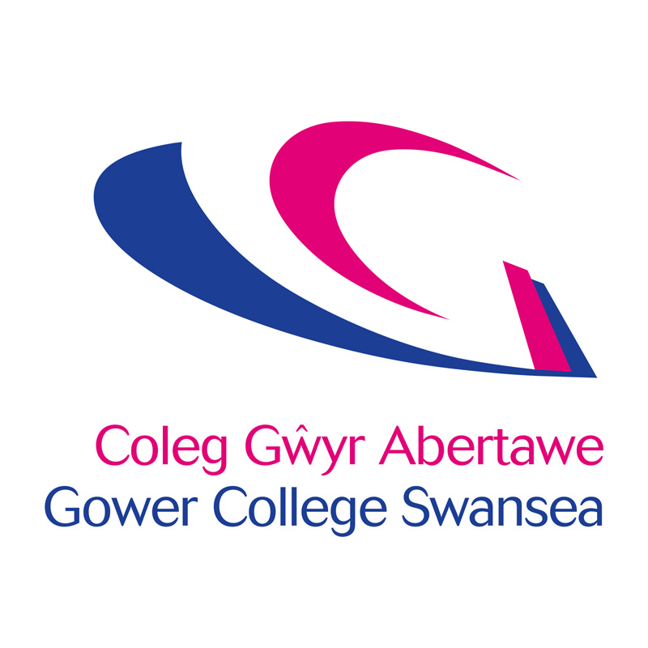
Job Description
Post: | Commercial Marketing Specialist
Accountable to: | Line managed by the Head of Employer Engagement  Matrix managed by the Marketing and Admissions Manager
Department: | Employer Engagement Team/Marketing

Job Purpose

To work with the Head of Employer Engagement and the Marketing and Admissions Manager to effectively manage, plan and execute a marketing strategy for GCS Training. This will also involve responsibility for line managing and mentoring support staff, as well as budgetary controls.

Key Responsibilities

- Work with the College's corporate Marketing Department to ensure a consistent and aligned approach to raising the profile of the commercial portfolios which include GCS Training and Work Based Learning.

- To create a marketing, communications and digital plan specifically designed to support achievement of targets for GCS Training.

- Review, manage and maintain the marketing, communications and digital plans to ensure they generate brand visibility, awareness and return on investment.

- Manage all external marketing and communications for the commercial areas of GCS Training.

- Line manage and mentor Digital Marketing Apprentice within the Employer Engagement team, participate in Apprentice review meetings.

- Work across the College to develop case study material to design collateral for future marketing and social media activities

- Manage all design and production as well as budgetary control of all print marketing literature for the commercial areas as required.

- Manage and plan all digital marketing activities (including social media platforms such as Facebook, twitter, LinkedIn) for the commercial areas of the College GCS training.

- Work with the wider team to draft, edit and quality assure engaging content for College's commercial websites and social media platforms.

- Monitor the development and engagement of online activities and report on expansion of digital audience.

- Ensure consistent use of the College’s branding across all elements of programme delivery.

- Produce an annual calendar of strategic events to attend, negotiate sponsorship to generate greater visibility of the commercial portfolios.

- Represent the College at a variety of promotional and networking events – collating contacts and reporting back to The Employer Engagement Team.

- Work with the corporate Marketing Department to support with cross College events, for example open evenings, awards ceremonies and graduation.

- Manage all memberships and associations for the commercial areas to ensure opportunities for brand alignment and recognition are maximised.

- Undertake research (online and traditional) to determine the effectiveness of campaigns and utilise to review/revise future content plans.

- Utilise and adapt the College's CRM system to maximise marketing opportunities, with targeted campaigns, ensuring full compliance with GDPR, record data and monitor use, as well as targeted mail campaigns.

- Manage the marketing and communications budget for the Employer Engagement team, and review monthly with the Head of Employer Engagement and the Marketing Manager.

- Maintain a high level of communication with departments across the College to ensure staff are aware of and engage with the commercial marketing activities.

- Present to monthly team meetings providing updates on campaigns.

- Participate in monthly one to one meetings with the Head of Employer Engagement to included budget updates as well as return on investment data for all campaigns.

- To work flexibility between campuses depending on the needs of the business.

OTHER TASKS

- Comply with all College Policies & Procedures, keeping abreast of any changes and updating practice and/or systems to ensure continued compliance.

- Ensure that all aspects of the College Financial Regulations are followed.

- Contribute to and represent the overall vision and values of the College.

- Ensure that all services are delivered in compliance with the Welsh Language Standards.

- To flexibly respond to the needs of the business and to provide an effective service to our learners and other stakeholders.

PERSONAL DEVELOPMENT

In partnership with the College, take responsibility for personal development, including:
1. Participating in an annual staff review and identifying development needs.
2. Updating of professional, teaching and training skills and qualifications, through attending staff development opportunities, joining professional bodies and keeping informed of educational and professional initiatives.

HEALTH & SAFETY

All employees have a statutory duty of care for their own personal safety and that of others who may be affected by their acts or omissions. Staff are required to co-operate with management to enable the College to meet its own legal duties and to report any hazardous situations or defective equipment.

GENERAL

This description is not intended to establish a total definition of the job, but an outline of the responsibilities you are expected to undertake. From time to time you may be required to undertake any other duties commensurate with your level of responsibility.

This is a description of the job as it is at present constituted. It is the practice of the College periodically to examine employees’ job descriptions and to update them to ensure that they relate to the job as then being performed, or to incorporate whatever changes are being proposed. You will, therefore, be expected to participate in any discussions relating to Job Description change.

Person Specification – Commercial Marketing Specialist
The Person Specification identifies essential criteria needed for the job.
The criteria are job-related, justifiable and non-discriminatory.
In your application you are asked to address only those criteria labelled A.
These will be used to shortlist applicants.
Criteria | Essential | Desirable | Method
Qualifications | Educated to degree level or equivalent.  A recognised qualification in Marketing/PR or equivalent experience. | Experience of project management. | A  A
Knowledge and  Experience | Experience of delivering integrated marketing communication campaigns both online and offline.  Proven experience of producing marketing materials for various audiences including knowledge of working with external agencies.  Proven experience of implementing digital marketing tactics including a strong understanding of social media platforms.  Proven experience and knowledge of public relations including liaison with the media.  Experience of planning and delivering events targeted at various audiences.  Experience of working with B2B. | Knowledge of further education marketing.  Experience of working in a busy marketing environment.  Line management. | A/I  A/I  A/I  A/I  A/I
Skills and  Abilities | Excellent written, verbal and presentation skills including the ability to turn complex information into plain copy.  Excellent attention to detail.  Ability to communicate effectively and network at all levels.  Ability to plan and prioritise tasks effectively.  A track record of delivering objectives against tight deadlines.  Ability to project manage tasks effectively and produce output reports to show return on investment. |  | A/WRE  I/WRE  I  I  I  A
Personal Attributes | Ability to work effectively as part of a team.  Excellent interpersonal and organisational skills.  A positive and proactive approach, prepared to generate new ideas and carry them forward. |  | I  I  I
Special  Requirements | Flexibility to work across campuses as and when required.  Flexibility of work hours, willing to work evenings and weekends when required. | Welsh language skills – Level 4  (See detailed language level descriptors attached). | A

A – Application Form
I – Interview
WRE – Work Related Exercise

WELSH LANGUAGE LEVEL DESCRIPTORS
DISGRIFYDD LEFEL IAITH GYMRAEG

Welsh Essential | LEVELS | Listening | Speaking | Writing | Reading
 | Level 4  Proficient | Able to understand all conversations involving work | Fluent – able to conduct a conversation and answer questions, for an extended period of time where necessary | Skilled – able to complete complex written work without the need for revision | Able to understand all material involving work
 | Level 3  High | Able to follow the majority of conversations involving work including group discussions | Able to speak the language in the majority of situations using some English words | Able to prepare the majority of written material related to the area, with some assistance in terms of revision | Able to read the majority of material in own area
 | Level 2  Intermediate | Able to follow routine conversations involving work between fluent Welsh speakers | Able to converse with someone else, with hesitancy, regarding routine work issues | Able to draft routine text, with editing assistance | Able to read routine material with a dictionary
 | Level 1  Foundation | Able to understand a basic social conversation in Welsh | Able to answer simple enquiries involving work | Able to answer simple correspondence with assistance | Able to read basic material involving work (slowly) and understand text that consist mainly of high frequency everyday work related language
Welsh Desirable | Entry | Able to understand basic enquiries in Welsh (“Ble mae…? Ga’ i siarad â…?”) | Able to conduct a general conversation (greetings, names, sayings, place names) | Able to write basic messages (“Diolch am dy help.”) | Able to understand and read very short, simple texts
 | None | No Welsh language skills at all | No Welsh language skills at all | No Welsh language skills at all | No Welsh language skills at all

DISGRIFYDD LEFEL IAITH GYMRAEG
WELSH LANGUAGE LEVEL DESCRIPTORS

Cymraeg Hanfodol | LEFEL | Gwrando | Siarad | Ysgrifennu | Darllen
 | Lefel 4  Rhugl | Gallu deall pob sgwrs yn ymwneud a’r gwaith | Rhugl – gallu cynnal sgwrs a gofyn cwestiynau, am gyfnod estynedig pan fod angen | Medrus – gallu cwblhau gwaith ysgrifenedig cymhleth heb angen adolygu | Gallu deall deunyddiau yn ymwneud a’r gwaith
 | Lefel 3  Uchel | Gallu dilyn y mwyafrif o sgyrsiau yn ymwneud a’r gwaith yn cynnwys trafodaethau grwp | Gallu siarad yr iaith yn y mwyafrif o sefyllfaoedd gan ddefnyddio rhai geiriau Saesneg | Gallu paratoi'r mwyafrif o waith ysgrifenedig yn ymwneud a’r maes, gyda pheth cymorth o ran adolygu | Gallu darllen y mwyafrif o ddeunyddiau yn fy maes
 | Lefel 2  Canolradd | Gallu dilyn sgyrsiau arferol yn ymwneud a gwaith, rhwng siaradwyr Cymraeg rhugl | Gallu sgwrsio gyda rhywun arall am faterion gwaith arferol, ond yn petruso | Gallu drafftio testun arferol, gyda chymorth golygu | Gallu darllen deunyddiau arferol gyda geiriadur
 | Lefel 1  Sylfaen | Gallu deall sgwrs gymdeithasol sylfaenol yn Gymraeg | Gallu ateb cwestiynau sylfaenol yn ymwneud a’r gwaith | Gallu ateb gohebiaeth gyda chymorth | Gallu darllen deunyddiau syml yn ymwneud a gwaith (yn araf) a gallu deall testun sy’n cynnwys iaith gwaith pob dydd yn bennaf
Cymraeg Dymunol | Mynediad | Gallu deall ymholiadau sylfaenol yn Gymraeg (“Ble mae…? Ga’ i siarad â…?”) | Gallu cynnal sgwrs gyffredinol (cyfarchion, enwau, dywediadau, enwau llefydd) | Gallu ysgriffennu negeseuon sylfaenol (“Diolch am dy help.”) | Gallu deall a darllen testunau byr, syml iawn
 | Dim | Dim sgiliau Cymraeg o gwbl | Dim sgiliau Cymraeg o gwbl | Dim sgiliau Cymraeg o gwbl | Dim sgiliau Cymraeg o gwbl

