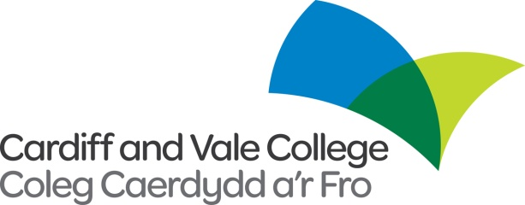

**Internal / External Vacancy**

**Job Title:** Learning & Skills Coach

**Contract:** 1 x Fractional (30 Hours, fixed-term to 31/7/2022, Term Time Only)

**Salary:** £21,925 - £23,797 pro rata

An exciting opportunity has arisen within Cardiff and Vale College for a term-time only Learning & Skills Coach within the Learner Success department.

The successful candidate for the post will be responsible for providing support to those students identified as having skills needs in literacy, numeracy, ESOL and digital skills, or those ‘at risk’ of leaving college.

Responsibilities include:

* Being a Learning Coach - providing students with appropriate levels of support and guidance to help them understand their learning styles, utilising coaching processes to enable the learners to learn more effectively.
* Working with teaching staff to maximize the student’s ability to learn and to remain in learning, and to achieve qualifications in either or both academic and vocational areas.
* Liaising with teaching staff to identify reasons for underachievement with students and implementing a variety of tools such as referral, 1:1 and group work, challenging target setting on ILPs and building learners’ motivation and confidence levels.
* Providing support (in-class, directed private study, appointments and drop-in Skills Centre support) to those students/staff identified as having skills needs in literacy and/or numeracy, as well as support with IT and academic English (at all levels pre-entry to HE and professional).
* Offering students support with UCAS personal statement writing and study skills including Academic Writing, Presentation Skills; Time Management, Plagiarism and Referencing.
* Assisting teaching staff in the utilisation of the Wales Essential Skills Toolkit (WEST) to ensure the completion of initial assessments and progression of skills for learners.
* Drawing up individual learning plans (ILPs) for students in collaboration with them, Essential Skills Tutors and Course Tutors as and when appropriate.

The successful applicant will be educated to level 3 in a relevant subject and have English and Maths GCSE, grades C or above. Possession of an Essential Skills Practitioners, Basic Skills, Learning Coach and a PTLLS qualification is highly desirable or having a willingness to work towards these, as appropriate. Applications from Welsh speakers are welcomed although this is not an essential element of the role.

Applications are to be made using the Cardiff and Vale College application form only. The college welcomes applications in Welsh. Applications submitted in Welsh will not be treated less favourably than an application in English. If we invite you to interview, let us know if you would like us to conduct the interview and assessment process in Welsh.

**The closing date for completed applications is 28/10/21 at 12pm**

To find out more or apply go to [www.cavc.ac.uk](http://www.cavc.ac.uk) or contact the Human Resources Department on 02920250311 or hr@cavc.ac.uk.

All vacancies are subject to a Disclosure and Barring Service (DBS) check and employment will not commence without a valid up to date DBS check. This is a contractual agreement that must be in place before your employment starts. The College’s procedure for the Suitability of Ex-offenders for Employment is available upon request.

Your employment with Cardiff and Vale College will also be dependent on suitable reference checks, before you are able to commence employment, Cardiff and Vale College must have received two references, one being from your present or most recent employer. We will contact your referees upon appointment.

Registration with the Educational Workforce Council for Wales (EWC Wales) is a mandatory requirement of the post

**These are contractual agreements that must be in place before your employment can commence.**

We are committed to the recruitment and retention of disabled people, and are a positive disability confident scheme employer.

 cid:image005.jpg@01D77EFE.93A73200 